DENTAL CARE
Dental exams are by appointment only for active duty members and are required annually within 30 days of your birth date. Appointments for dental cleanings are scheduled at six month intervals.
To schedule a cleaning with the hygienists or a dental exam with our Dental Officer, please contact the Medical front desk at (503) 861-6240.
The Dental Clinic does not provide services to family members. Eligible family members use United Concordia Dental https://www.uccitdp.com/dtwdws/member/landing.xhtml or you may call 1-844-653-4061 to speak to a customer service representative.
As part of the Patient Centered Wellness Home, Sector Columbia River Dental Clinic provides primary care services for active duty personnel and reservists on orders. Each active duty member will be part of an internal Dental Team that will attend to your healthcare needs.
Dental Home Team Members Are:
- CDR Robert Lummis – Dental Team Leader
- Melissa Perry – Dental Assistant
- Suzanne Jagger – Dental Hygienist

You may reach your Dental Team Members via e-mail or by calling (503) 861-6243.

Tricare services
TRICARE at 1-844-866-9378 or http://tricare.mil/
Main information regarding TRICARE and enrollment can be sourced through either calling TRICARE or going online.
Signing up on https://www.tricare-west.com is a quick and easy way to find providers, monitor referrals, authorizations and access to your Explanation of Benefits (EOB). Additional information regarding provider searches and the mail order Pharmacy program is available on the web at https://www.tricare.mil/

DEERS: Incorrect DEERS information may cause delays in receiving referrals and cause claims to be processed improperly resulting in you or your dependents being charged for covered medical benefits. Please update your address and dependent information at Sector Personnel Office upon reporting aboard AND with any subsequent changes at: www.tricare.mil/deers

Advance Directives (Living Wills)
CG health care facilities are not required to provide such information under the law. You may contact your unit Legal Officer for further assistance.

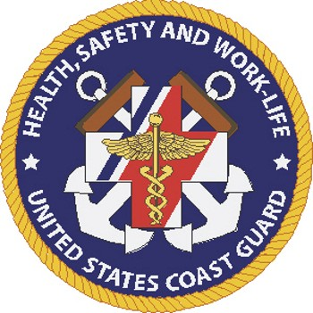

USCG Sector Columbia River

Health Services Clinic
2185 SE 12th Place
Warrenton, OR 97146
Tel: (503) 861-6240
Fax: (503) 861-6358
Clinic and Medical Information: http://www.uscg.mil/d13/sectcolrvr/services/medical.asp

grievances
All grievances or requests to change primary care managers will be addressed by the Health Services Administrator, HSC Derek Williams at (503) 861-6240. You are also welcome to attend one of our quarterly scheduled Patient Advisory Committee (PAC) meetings, a forum utilized to address patient needs and concerns. Contact the front desk for information on the next scheduled PAC meeting.
USCG Sector Columbia River
Health Services Clinic
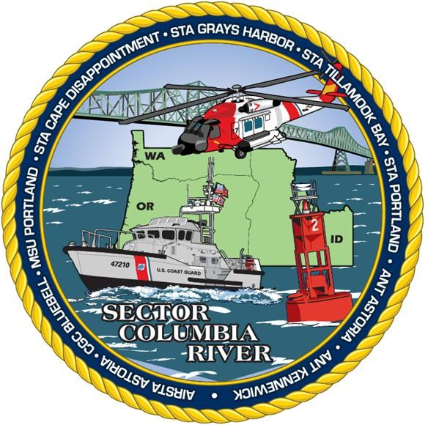
“Providing Quality Health Care for our Coast Guard Family”

MISSION STATEMENT
Our mission is to provide the highest quality healthcare to our active duty and reserve with a primary focus on operational readiness, mission support, and patient satisfaction by delivering superior, responsive and comprehensive health services, supporting individual wellbeing and the full range of CG Missions.

Welcome to the
Sector Columbia River Health Services Clinic

Patient centered wellness home
A Patient Centered Wellness Home Model is a team of medical and dental providers and support staff who deliver services for total healthcare, surrounding the patient with support to accomplish wellness goals. This healthcare model will include and coordinate the disciplines of medicine, dentistry, pharmacy, family support, work-life, and safety, forming the Patient Centered Wellness Home. Each patient is expected to actively participate in developing individualized health and wellness directives and goals with their assigned team.

Clinic scope of practice
Your Clinic Team will attend to your healthcare needs. Coast Guard Sector Columbia River Medical/Dental department provides services and support functions for Sector units as well as other local Coast Guard units. The medical facility at the Sector services all active duty personnel within the Sector coastal area of responsibility. It also provides a limited amount of care to reservists. The medical facility is a limited service medical and dental clinic. If the clinic cannot handle the nature of the medical or dental ailment, the patient may be referred to Columbia Memorial Hospital in Astoria, Providence Medical Group in Seaside, and Madigan Army Medical Center in Tacoma, WA. or to another local doctor/dentist. In some cases patients may get referred to a TRICARE network doctor in Portland. Patients are seen for routine and acute care by appointment only and may be scheduled by calling or visiting the front desk.
We encourage you to address any questions concerning your care to the Medical Team Members listed or by contacting the front desk at (503) 861-6240 or via e-mail. Your concerns and questions are important to us. Your Medical Team Member will promptly consult with your provider and either answer your questions or schedule you for a visit.

Hours of Operation
0730 – 1600
Monday through Friday
Limited Operations on Wednesday Afternoons

after hours care
Team Columbia River maintains a 24 Hour on-call service to address urgent care needs. All active duty personnel are responsible for contacting the Team Duty HS after hours prior to seeking urgent/non-life threatening care. You may contact the Team Duty HS at (503) 338-8751.
EMERGENCY CARE – Call 9-1-1, or go to the nearest Emergency Department as soon as possible. Notify the Duty HS and Command of the emergency room care and/or admittance to the hospital.
RESOURCES
ON/OFF BASE  EMERGENCY: | 911
Appointments / Front Desk | (503) 861-6240
Team Duty HS | (503) 338-8751
Nurse Advice Line | 1-800-874-2273, Option 1
Clinic Supervisor: | (503) 861-6444
Clinic Administrator | (503) 861-6244
Physical Exams Appointment Line | (503) 861-6240
TRICARE (West region) | (844) 866-9378
Seattle Work-Life | (206) 217-6786
Child Development Specialist  (Kelly Smitherman) | (503) 861-6242
Express-Scripts Pharmacy | (877) 363-1303
Active Duty Dental Plan | (866 ) 984-2337
United Concordia Dental Plan (dependants) | (844) 653-4061
CG SUPRT (EAP) | (855) 444-8724
Sector Ombudsman: Mrs. Stephanie Davenport
SectorCRombudsman@gmail.com

Health care Providers
Team Sector Columbia River:
Medical Home Team
- Dr. Kristopher Wagner-Porter, M.D.
- LCDR Claire Reilly, PA-C
- HSC Derek Williams (Clinic Administrator)
- HS1 Michael Henry (Clinic Supervisor)
- HS1 Eric Davenport (Outpatient/Med Boards)
- HS2 Jodi Hardy (PHA/OMSEP)
- HS2 Nathan Goodrich (Outpatient)
- HS3 Daniel Jackson (Physical Exams)
- HS3 Vanity Salas (Lab)
- HS3 Stephen Slonaker (Outpatient)
- Ms. Chelsey Frank (Health Benefits Advisor / Referrals & Authorizations)
Dental Home Team
- CDR Robert Lummis (Dental Officer)
- Ms. Melissa Perry (Dental Assistant)
- Ms. Suzanne Jagger (Dental Hygienist)

physical examinations
A full range of required physical examinations are provided by appointment. For all types of physicals, please contact the Front Desk at (503) 861-6240 to inquire as to availability and scheduling.

pharmacy services
Sector Columbia River Clinic has a limited capability Pharmacy with the ability to provide prescriptions for emergent and acute care needs. Routine prescriptions and chronic medications will be filled through civilian, TRICARE approved, pharmacies or through the Mail-Order Pharmacy program. The Pharmacy does offer a well stocked Over-The-Counter (OTC) program. We strongly encourage use of this benefit. Families are limited to 2 items per week. All aviation personnel should consult their Medical Team Members prior to taking any medication that may impair their abilities.

